Workshop 4 — Student Handout (Consultant Management)
Task Type: HTML + CSS (Beginner)
Your Work: Complete the remaining 20% of the webpage
You receive: 80% completed index page and stylesheet

✅ What You Must Do (20% Work)
A. HTML Tasks
- Add the site logo image inside the header area and include meaningful alternative text.
- Add the missing navigation menu items (Destinations, Manage Tours) as proper links in the navbar.
- Ensure navigation items are accessible (use role/aria-label attributes where appropriate).
- Add any missing summary boxes (Pending, Total Bookings) so the summary area shows four boxes in total. Each box should have an emoji/icon, a title, and a numeric value.
- Ensure the "Add Consultant" control is clearly labelled and accessible.
- Replace image-only action controls in the table (view/edit/profile/delete) with accessible controls — e.g., buttons or links that include text or aria-labels.
- Convert footer list items into working links (at least two links required). Ensure footer images and icons have meaningful alt text.
B. CSS Tasks
- Add styling for the nav-logo image so it looks correct in the navbar.
- Add styles for any summary boxes you add (e.g., box-yellow, box-lightblue) to match the page theme.
- Add hover/focus styles for table rows and action controls for better UX.
- Add visual styles for footer links (link color, hover state) and ensure footer layout looks balanced.
- Ensure the Add button and table action controls have accessible focus outlines and hover effects.

📌 Minimum Requirements (Checklist)
• Header has a visible logo image with alt text.
• Navbar contains all main links (Home, Destinations, Manage Tours, Booking Requests, Manage Consultants).
• Summary area includes four boxes (Total Consultants, Active, Pending, Total Bookings) with values.
• Action controls in the data table are accessible and usable (not image-only).
• Footer contains at least two working links.
• Page displays tidy basic styling and aligns properly on desktop.
Given Output
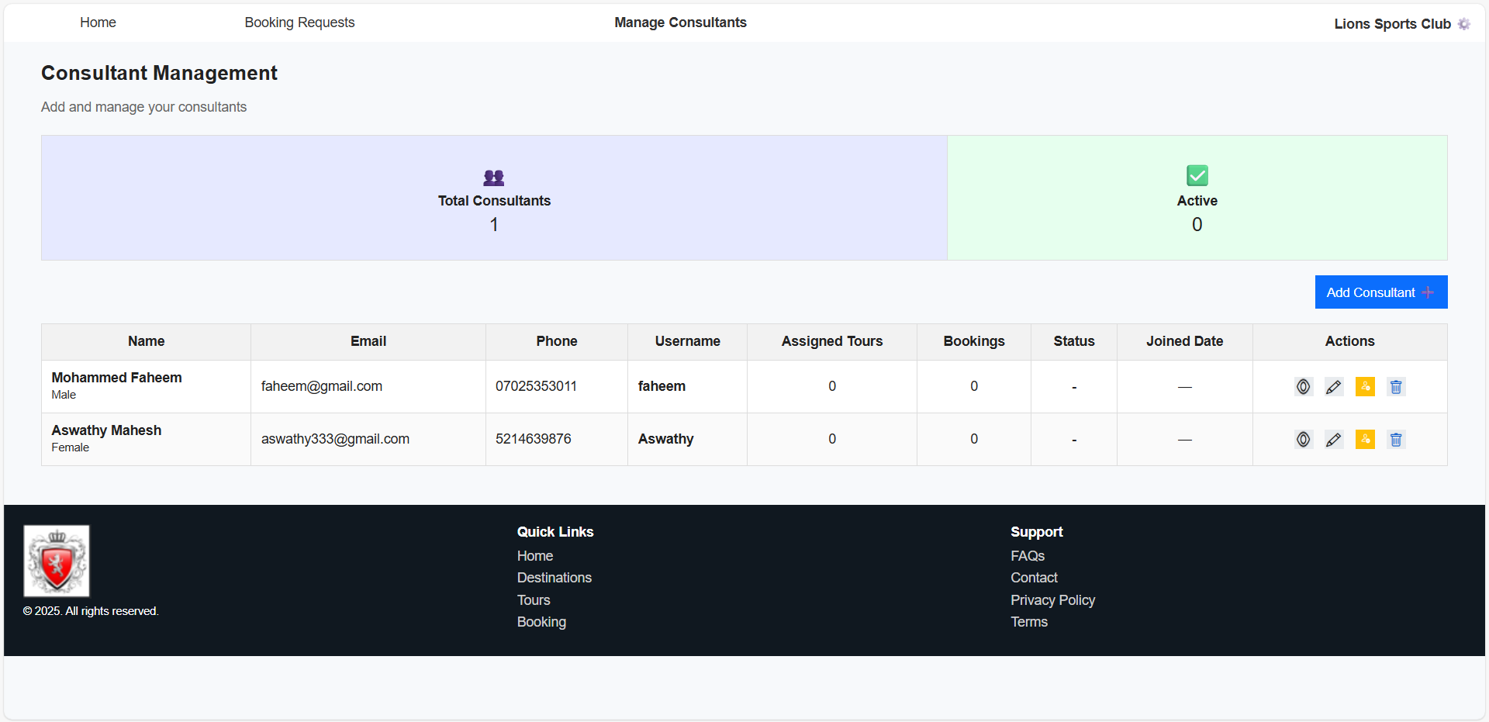

Expected Output
